Volume 1, Issue 1

May 4, 2017

Second Vice President: Sidney Ropp

Hello! My name is Sidney Ropp, and I am currently a freshman at Tremont High School. Student council has been a significant part of my life since I first joined in fifth grade. Therefore, I am very excited to serve the Hopewell District as Second Vice President. Outside of student council, I am a member of the scholastic bowl team, and when I’m not at school, I love to write novels and play piano. Although I am currently undecided on what I want to study once I graduate high school, political science, creative writing, and Spanish are the main college majors I am considering. Thank you for your involvement in student council, and I hope that the 2017-2018 school year will be amazing!

Meet the New Hopewell Officers!

President: Kimberly Roskamp

First Vice President: Morgan Patrick

Hello, I am Kimberly Roskamp. I am very excited to be your new president. I am a sophomore, almost junior, at Midwest Central High School. This past year I have been a part of volleyball, cheerleading, and track. I am also involved in many in-school and out-of-school clubs. Student Council, however, is my favorite. Student Council and Hopewell both have offered me a chance to experience so many great things, and I am very excited to see where this year goes. Thank you for allowing me to be your 2017-2018 President.

My name is Morgan Patrick, I am a sophomore at Abingdon-Avon High School, and I am delighted to say that I will be the First-Vice President of the Hopewell District this upcoming year. I participate in softball, basketball, art club, key club, student council, Trio Upward Bound, and I am class President. I am so excited to be a part of the Hopewell District Board and can’t wait to see what this next year has to come.

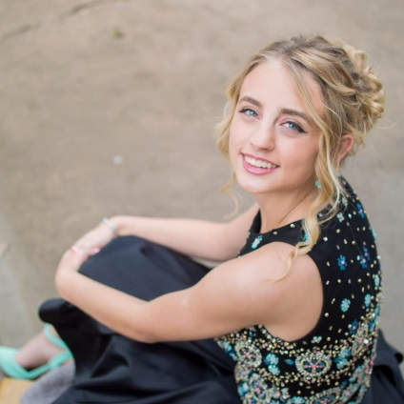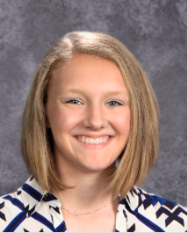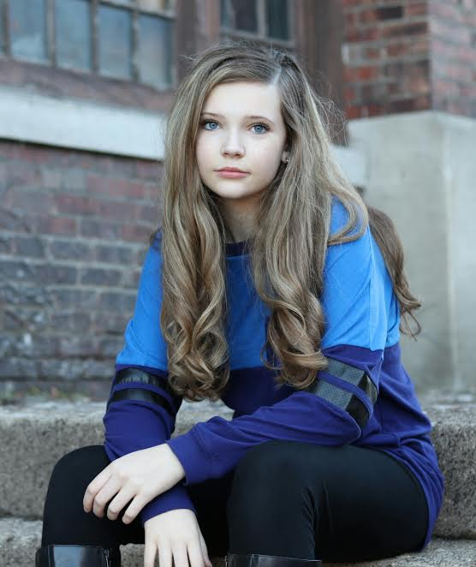

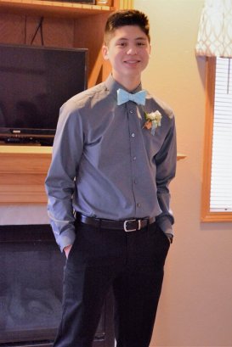

Recording Secretary: Noah Farnam

Hello, my name is Noah Adrian Farnam. I am a freshman at Midwest Central High School. This is my first year on the high school student council. I am a part of basketball, baseball, History League, and Spanish. I am expecting a great year from our board, and I am very excited to be your new Secretary.

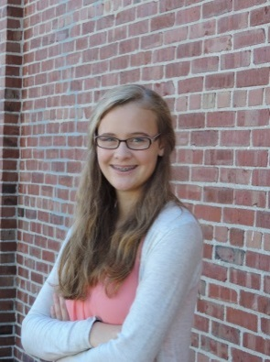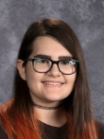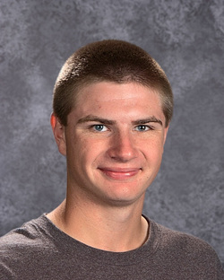

Treasurer: Reka Jeckel

Hi! My name is Reka Jeckel and I am a junior at Delavan High School. I am your 2017-18 District Treasurer. Besides student council, I am involved in many other activities at my school. I’m in track, drama club, WYSE, national honors society, band, choir, and the Junior Class Treasurer. Outside of school, I love to play the piano, read, go to youth group, and, of course, hangout with my friends and family. I am so blessed to have this opportunity to serve all of you and I am super excited for the year ahead!

Convention Secretary: Josh Goetze

Hello, I am Josh Goetze! As I head into my senior year at Midwest Central, I look forward to holding the office of Convention Secretary. In my school, I am involved in FFA, NHS, and Interact. I am also a member of both the basketball and baseball team. My hobbies include hunting, fishing, and playing sports. My favorite team in the MLB is the Cardinals. In my free time, I enjoy hanging out with my friends. I am excited to see what the 2017-2018 year has in store for the Hopewell District!

My name is Bri Davis, I’m a sophomore at Tremont High School, and I am the new 2017-2018 Hopewell District Liaison. I’ve been on my own council both years of high school. My whole sophomore year I have also been on Tremont’s executive board as the secretary. Student Council is the main extra-curricular I participate in, but I’m also in Scholastic Bowl and always take some part in the school play. After high school, I hope to attend Illinois State University and study English Education, hopefully as well as something with theatre, and become a high school English teacher.

Liaison to IASC: Bri Davis

I am pleased to announce that the 2017-2018 Service Project will be Special Olympics! Special Olympics grants opportunities for children and adult athletes with intellectual disabilities. Intellectual disabilities are described as a person who has certain limitations in cognitive functioning and other skills. Special Olympics provides year-round training to over 5.3 million athletes in nearly 170 countries. They also help raise awareness about the abilities of people who have intellectual disabilities. Like the regular Olympic games, the Special Olympics World Games alternate between summer and winter games and are held every two years. I have decided to choose this organization because it would be a great organization to support. They do a lot of local events, including the Polar Plunge, that councils could participate in to help grow as a council while supporting an organization that continually changes people’s lives every day.

Introducing the 2017-2018 Service Project

Getting to Know Your Officers

*Written by President Kimberly Roskamp*

If you could only eat one food for the rest of your life, what would it be?

Reka Jeckel: Any kind of pasta.

Bri Davis: It’s too much commitment to choose only one food!

If you could do any job in the world, what job would you do?

Sidney Ropp: Although I would have to live far away from home, being a television writer for a teen drama would be incredible.

Kimberly Roskamp: I would want to be a counselor for kids.

What are you most excited about for the 2017-2018 year?

Noah Farnam: All of the great memories we are going to make.

Morgan Patrick: Gaining more leadership skills through the Hopewell District Board and clubs at my school.

Josh Geotze: I am most excited for Fall Workshop and Spring Convention.



